1. display all suppliers who statys in state either in california

or Texas or Arkansas

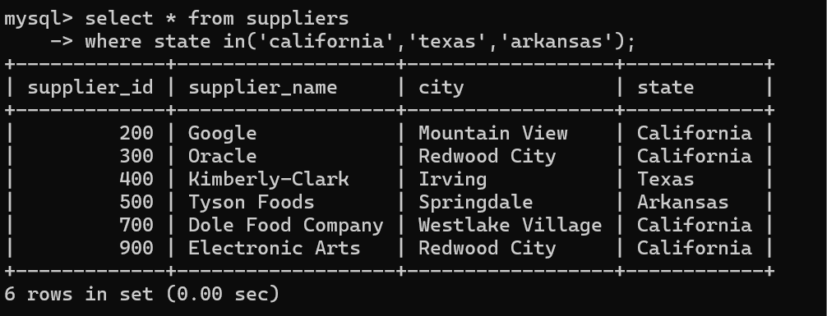

3. list all suppliers who does not stay in Springdale

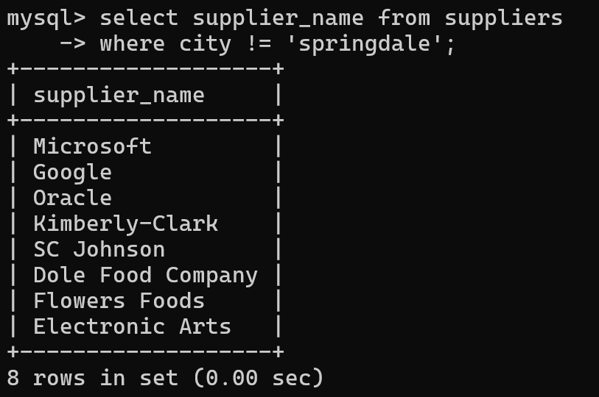

3. find orderid and customerid for orders place on date 18-feb-16

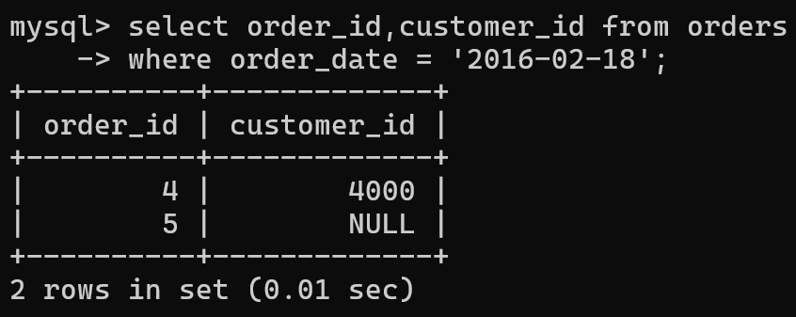

4. find orderid and customerid for orders place on feb 2016

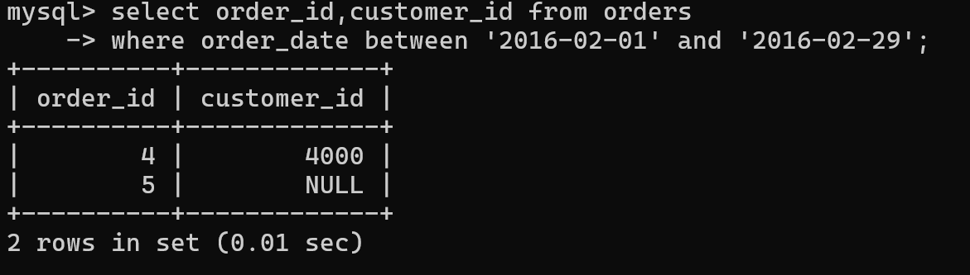

5. find all customers with name 'Reynolds', or Anderson

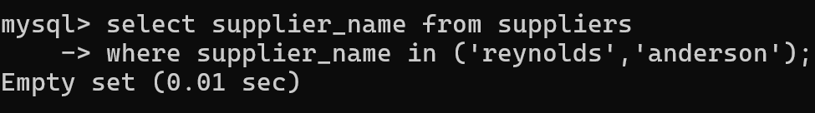

6. find all suppliers with supplierid >=200 and <=700

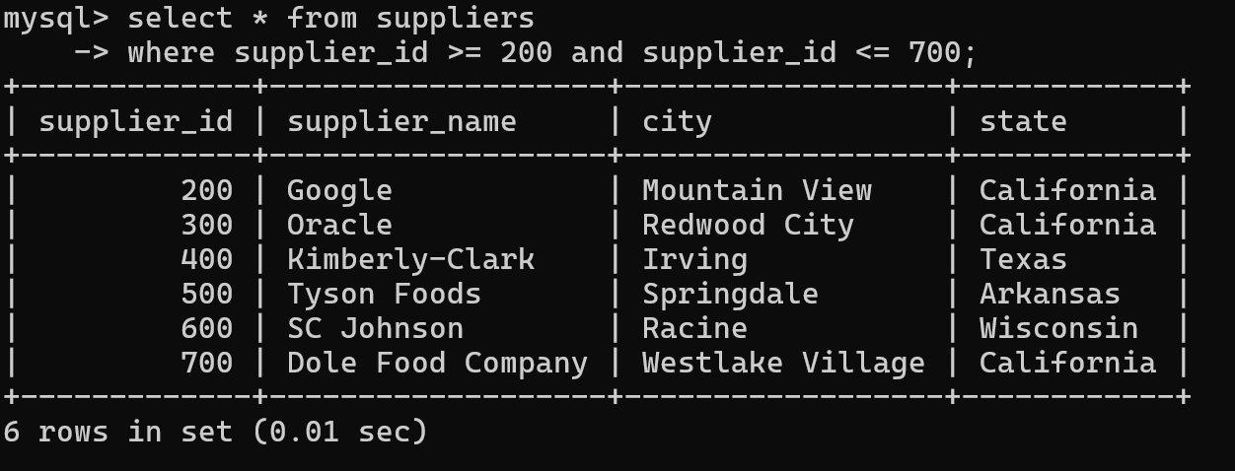

7. find all customers for whome favorite_website is not given

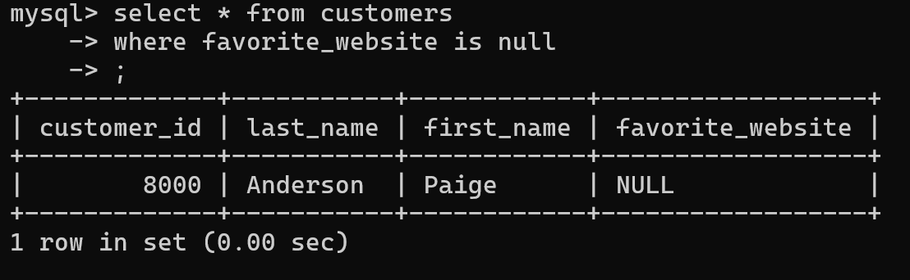

8. find all customers for whome favorite_website is given

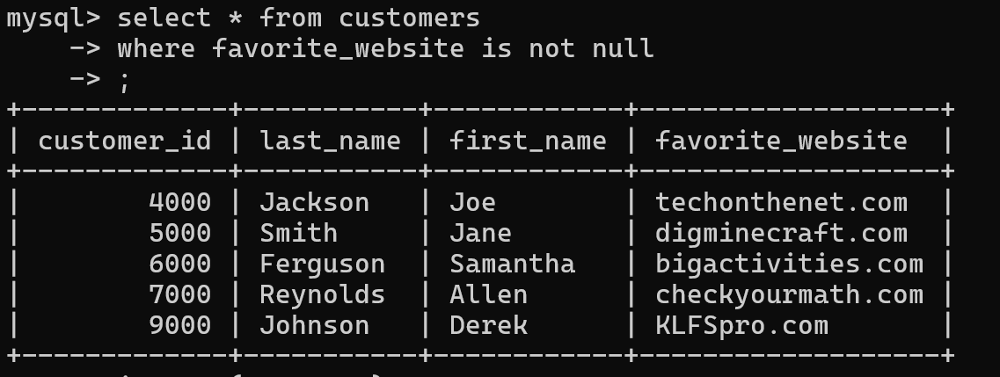

9. find all suppliers with supplierid not >=200 and not <=700

